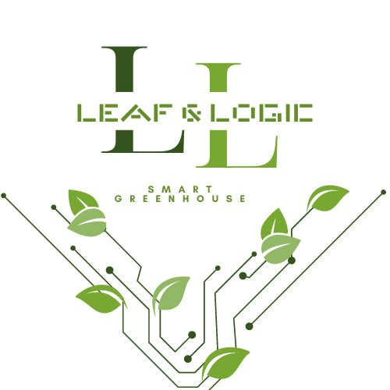

Submitted by: Jordie, David & Raj Submitted on: February 14, 2024
Project Scope:
Justification:
Leaf & Logic’s Eco-Friendly Smart Greenhouse Controller addresses the need for a cost-effective, customizable, and sustainable solution to enhance plant growth and greenhouse management. By integrating advanced environmental controls with innovative plant stimulation techniques such as music and programmable LED light patterns, this project stands out from existing smart greenhouse solutions. Its design caters to eco-conscious gardeners, educators, and small-scale greenhouse operators who seek to leverage technology for improved plant care and agricultural education.
Our Eco-Friendly Smart Greenhouse Controller is a game-changer for those who lead hectic lives or occasionally let their gardening tasks slip their minds. It automates the important aspects of plant care, such as ensuring optimal light, water, and temperature levels, operating autonomously to keep your plants thriving, even amidst a busy personal schedule or lapses in memory.
This product is for individuals who've hesitated to venture into gardening due to their poor track record with plants. You don’t need a green thumb to succeed here; our system is engineered to take the guesswork out of gardening, employing technology to simulate healthy plant growth. This makes the art of gardening accessible and enjoyable for everyone.

Product scope description: The characteristics of the products, services, and/or results your project will produce. This is the project scope. You should include any interim goals. You may not reach the final product, but that is your complete goal.
Product Scope Description:
The project will deliver an integrated greenhouse management system built around a Raspberry Pi 4, capable of monitoring and controlling temperature, humidity, watering, and light, while also offering unique features such as musical plant stimulation and customizable LED light patterns for plant growth.
Interim goals include setting up and programming the Raspberry Pi for basic environmental monitoring, integrating, and testing the water system, and implementing the sound and light stimulation systems. The complete goal is to deploy a fully operational, eco-friendly smart greenhouse controller that enhances plant growth and supports sustainable gardening practices.
Interim Goals:
- Initial Setup and Environmental Monitoring: The first phase of our project involves assembling the hardware components, including the Raspberry Pi 4 and necessary sensors, and programming the system to accurately monitor environmental conditions within the greenhouse. This step ensures the system can collect real-time data on temperature, humidity, and light levels, forming the basis for automated environmental regulation.
- Water System Integration and Testing: Subsequently, the project will focus on integrating an automated watering system. This involves setting up soil moisture sensors and connecting them to a water pump, allowing for irrigation based on the plants' hydration needs. The goal during this interim phase is to ensure reliable operation.
- Sound and Light Plant Stimulation Systems: Our innovative feature of the project is the implementation of sound and light stimulation systems. This phase includes programming the Raspberry Pi to control LED grow lights and speakers, allowing the experimentation with different light spectra and musical frequencies to determine their effects on plant growth for users. Since we do not have enough time to monitor the success in this area. We will mark our success by establishing control of the LED patterns and speaker through programming.
Complete Goal:
Our goal is to launch a fully working Eco-Friendly Smart Greenhouse Controller. This system isn't just about automating the usual gardening tasks to save time and reduce mistakes; it's also about using smart tech to improve how plants grow. By keeping an eye on the greenhouse environment and making changes when needed, our project makes it easy for anyone to get into gardening, no matter how much experience they have or how busy they are. We're aiming to help people grow healthy gardens with less impact on the environment, blending eco-friendly practices with the latest in gardening technology.
Acceptance criteria: The conditions that must be met before project deliverables are accepted. When will it be 'good enough'. When will the product be acceptable. This may not match the entire scope.
Acceptance Criteria:
- Accurate and reliable monitoring and control of greenhouse environmental factors (temperature, humidity, watering, light).
- Successful control of LED light patterns and speakers including be able to schedule such.
- User-friendly interface for customizing environmental settings and stimulation parameters.

Deliverables: The products, services, and/or results your project will produce (also referred to as objectives). Be specific about what interim deliverables will be produced. For example, interim deliverable 1 - able to display patient information; interim deliverable 2 - able to update patient information and so on.
Deliverables:
- Hardware Setup: Assembled system including Raspberry Pi, environmental sensors, relay module, LED grow lights, speakers, water pump, and filtration system.
- Software Development: Custom software for environmental monitoring, control logic, and user interface for system customization.
- Integration and Testing: Integrated system with fully functional environmental control and plant stimulation via sound and light.
- Documentation: Comprehensive user and technical manuals detailing setup, operation, and maintenance procedures.

Project Exclusions: Statements about what the project will not accomplish or produce. You need to be specific as to what cannot be done as well.
Project Exclusions:
- Provide solutions for large-scale commercial greenhouses.
- Include advanced AI or machine learning algorithms for predictive analysis or plant disease detection.
- Offer real-time remote monitoring or control capabilities via the internet.
- Support all possible plant species with optimized growth conditions; focus will be on common greenhouse plants.
Constraints: Restrictions that limit what you can achieve, how and when you can achieve it, and how much achieving it can cost.
Constraints:
- Limited budget of approximately $185-$330, restricting the choice of components and technologies.
- Project timeline of 10-12 weeks, requiring efficient management and coordination of tasks.
- Availability of specific sensors and system components may affect project progress.
- The system's effectiveness is limited to environmental factors controllable within a small greenhouse setup.
Assumptions: Statements about how you will address uncertain information as you conceive, plan, and perform your project.
Assumptions:
- Suitable environmental sensors, LED lights, and other components will be available within the project budget.
- The Raspberry Pi and associated hardware will be capable of handling the computational and control tasks required for the project.
- Musical and light stimulation will have a positive effect on plant growth, based on preliminary studies and assumptions.
- Users will have basic technical knowledge required for system setup and operation.

